

A

PROJECT REPORT

ON

#### Emotion Recognition

BACHELOR OF ENGINEERING

INFORMATION TECHNOLOGY

##### BY

Parth Vijay Raut Roll No: 33359

Under the guidance of Mr. Vinit Tribhuvan Sir

DEPARTMENT OF INFORMATION TECHNOLOGY

PUNE INSTITUTE OF COMPUTER TECHNOLOGY SR. NO 27, PUNE-SATARA ROAD, DHANKAWADI PUNE - 411 043.

AY: 2022-2023

SCTR’s PUNE INSTITUTE OF COMPUTER TECHNOLOGY

DEPARTMENT OF INFORMATION TECHNOLOGY

##### C E R T I F I C A T E

This is to certify that the Project Work entitled

##### Emotion Recognition

Submitted by Name : Parth Vijay Raut

Exam Seat No: .

is a bonafide work carried out under the supervision of Mr. Vinit Tribhuvan and it is submitted towards the partial fulfillment of the requirements of Savitribai Phule Pune University, Pune for the award of the degree of Bachelor of Engineering (Information Technology).



Date: Place:

### 

### Introduction

##### [ML-based applications](https://bluewhaleapps.com/ml-application-development) can detect emotions by learning what these body language traits (facial features, speech features, biosignals, posture, body gestures/movement, etc.) mean and apply this knowledge to the new set of data and information provided. This is how machine learning helps in emotion detection!

Today, advanced ML algorithms are available that can extract and leverage facial landmarks, voice features/activities, biosignals, body gestures/movements, motor behavioral patterns, and more, to detect emotions from various forms of data such as images, videos, etc. Using [the right ML algorithm](https://bluewhaleapps.com/blog/how-the-chosen-ml-library-and-algorithm-can-make-or-mar-your-project) as per the purpose and needs can help get accurate results in emotion detection.

According to Markets and Markets, the global emotion detection and recognition market size is projected to grow to USD 56 billion by 2024.

Emotion recognition is the process of identifying human emotion. People vary widely in their accuracy at recognizing the emotions of others. Use of technology to help people with emotion recognition is a relatively nascent research area.

# 

# Dataset

For this project, I used the [FER 2013](https://www.kaggle.com/c/challenges-in-representation-learning-facial-expression-recognition-challenge/data) dataset available on Kaggle. This was the only easily available dataset I could find for this task. The dataset contains CSV files that map the emotion labels to the respective pixel values of the image at hand.

It has 7 emotions/classes (0=Angry, 1=Disgust, 2=Fear, 3=Happy, 4=Sad, 5=Surprise, 6=Neutral) and as visible in the overview below, the classes are a little skewed.

The dataset looks something like :

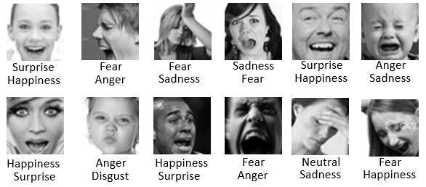

**Methodology**

The three main components of Emotion Detection are as follows:

1. Image Preprocessing
2. Feature Extraction
3. Feature Classification

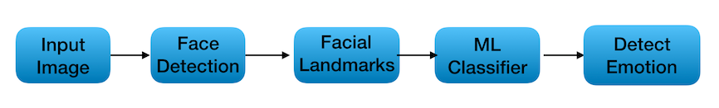

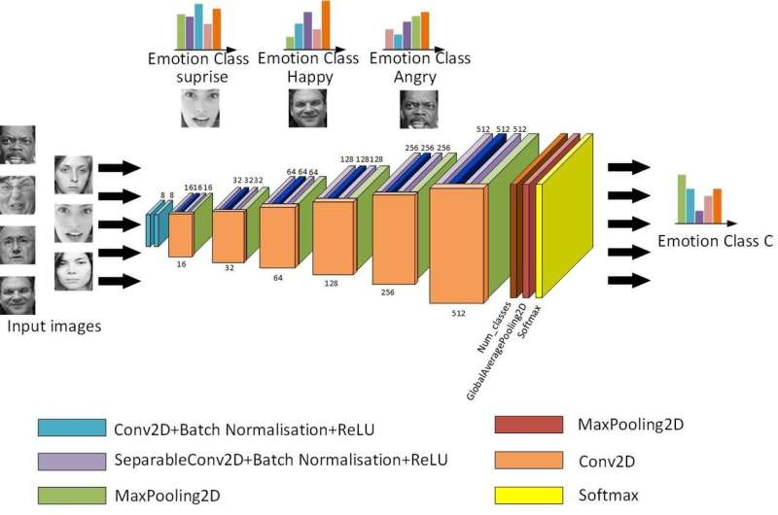

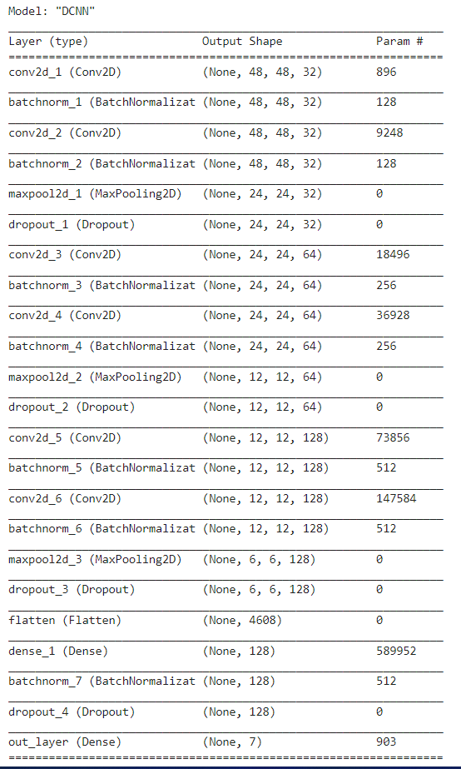

**References**

1. <https://towardsdatascience.com/emotion-detection-a-machine-learning-project-f7431f652b1f>
2. <https://bluewhaleapps.com/blog/implementing-machine-learning-for-emotion-detection>
3. https://techxplore.com/news/2019-05-convolutional-neural-network-facial-recognition.html